--Andmebaasi, tabelite loomine ning andmete sisestamine
create database School
use school

--Teacher table
create table Teacher
(
TeacherID int primary key,
Name nvarchar(50),
Teaching_Subject nvarchar(50),
Email nvarchar(100)
)

insert into Teacher values
(1, 'Peeter Kask', 'Math', 'P@K.com'),
(2, 'Mari Mänd', 'PE', 'M@M.com'),
(3, 'Kadri Tamm', 'Arts', 'K@T.com'),
(4, 'Albert Kask', 'English', 'A@K.com'),
(5, 'Mart Juurikas', 'IT', 'M@J.com')

select * from Teacher
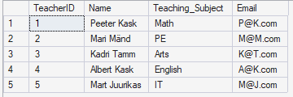

--Class table
create table Class
(
ClassID int primary key,
Class_nr nvarchar(10),
Room_nr nvarchar(10)
)

insert into Class values
(1, '7A', 'A101'),
(2, '8B', 'B202'),
(3, '7B', 'A107'),
(4, '9A', 'C100'),
(5, '6B', 'A222')

select * from Class
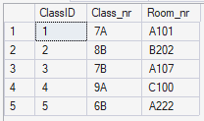

--ClassTeacher table
create table ClassTeacher
(
ClassTeacherID int primary key,
TeacherID int foreign key references Teacher(TeacherID),
ClassID int foreign key references Class(ClassID)
)

insert into ClassTeacher values
(1, 1, 1),
(2, 2, 2),
(3, 3, 3),
(4, 4, 4),
(5, 5, 5)

select * from ClassTeacher
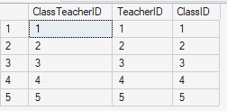

--Student table
create table Student
(
StudentID int primary key,
Name nvarchar(50),
Id_code nvarchar(50),
Email nvarchar(50),
ClassID int foreign key references Class(ClassID)
)

insert into Student(StudentID, Name, Id_code, Email) values
(1, 'Peeter Pets', '543564573', 'P@P.com'),
(2, 'Meeter Sent', '678467868', 'M@S.com'),
(3, 'Auto Ratas', '4234324523', 'A@R.com'),
(4, 'Oskar Luts', '67635464', 'O@L.com'),
(5, 'Sass Lass', '789078976', 'S@L.com')

select * from Student
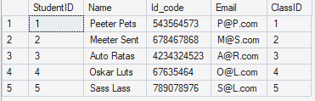

--subject table
create table Subject
(
SubjectID int primary key,
Subject_Name nvarchar(50),
Description nvarchar(500)
)

insert into Subject values
(1, 'Math', 'Math is math'),
(2, 'English', 'English is english'),
(3, 'PE', 'PE is PE'),
(4, 'IT', 'IT is IT'),
(5, 'Estonian', 'Estonian is estonian')

create table Grade
(
GradeID int primary key,
Date DATE,
GradeValue int,
StudentID int foreign key references Student(StudentID),
TeacherID int foreign key references Teacher(TeacherID),
SubjectID int foreign key references Subject(SubjectID)
)

insert into Grade(GradeID, Date, GradeValue) values
(1, '01.01.2026', 3),
(2, '03.05.2023', 4),
(3, '05.05.2025', 5),
(4, '04.09.2025', 3),
(5, '08.08.2020', 5)

select * from Subject
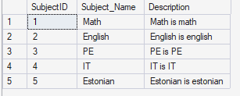

--Grade table
create table Grade
(
GradeID int primary key,
Date DATE,
GradeValue int,
StudentID int foreign key references Student(StudentID),
TeacherID int foreign key references Teacher(TeacherID),
SubjectID int foreign key references Subject(SubjectID)
)

insert into Grade values
(1, '01.01.2026', 3, 1, 1, 1),
(2, '03.05.2023', 4, 2, 2, 2),
(3, '05.05.2025', 5, 3, 3, 3),
(4, '04.09.2025', 3, 4, 4 ,4),
(5, '08.08.2020', 5, 5, 5, 5)

select * from Grade
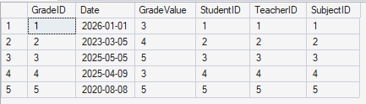

--stored procedure
create procedure sp_GetTeacherEmail
as begin
select Name, Email from Teacher
end

sp_GetTeacherEmail

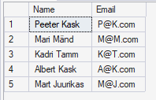

--1. join
select Class_nr, Room_nr, Name
from Class
left join Student
on Class.ClassID = Student.ClassID
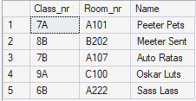

--2. join
select Name, Date, GradeValue
from Student
left join Grade
on Student.StudentID = Grade.StudentID
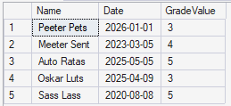

--3. join
select Subject_Name, GradeValue
from Subject
left join Grade
on Subject.SubjectID = Grade.SubjectID
